**GITHUB FIREBASE APP**

**1. BACKEND**

**STACK**

* Django
* Django REST Framework
* PyGithub (Github API)
* Firebase , Firebase Admin
* Postman (Test API)

**REQUIREMENTS**

* Need to create an API which takes data based on username from Github and upload to the Firebase FIrestore

**PROCEDURE**

* **Created a new DRF Custom API using DRF Viewset in views.py to fetch the data from the github(pyGithub) and further same to the database**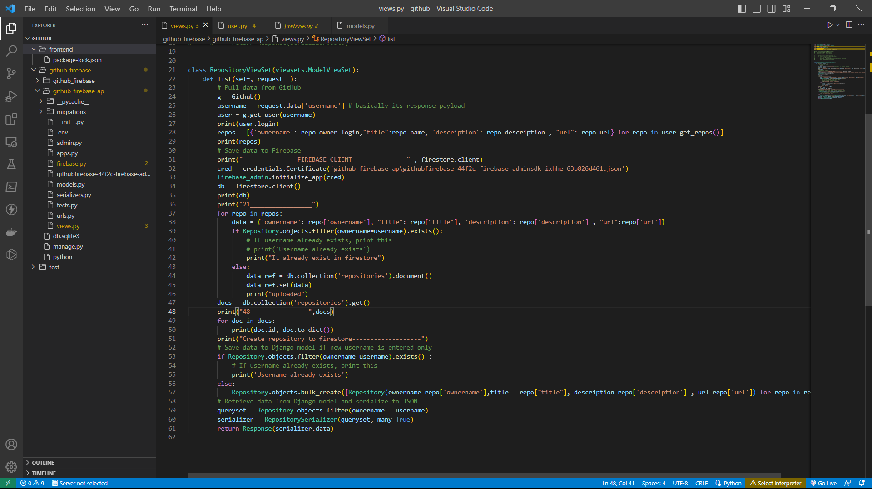
* **Created a model to store relevant details from github repo** 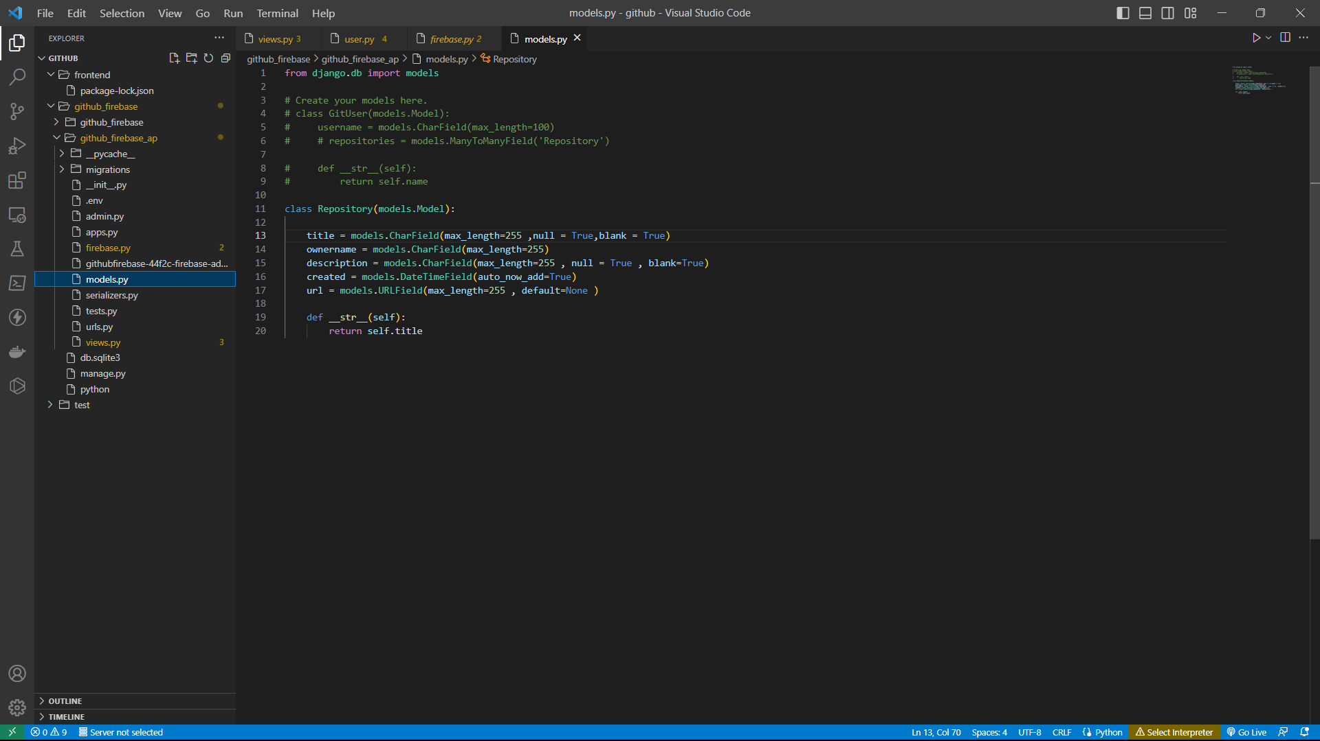
* **Adding the serializer and URL Roung for API**
* 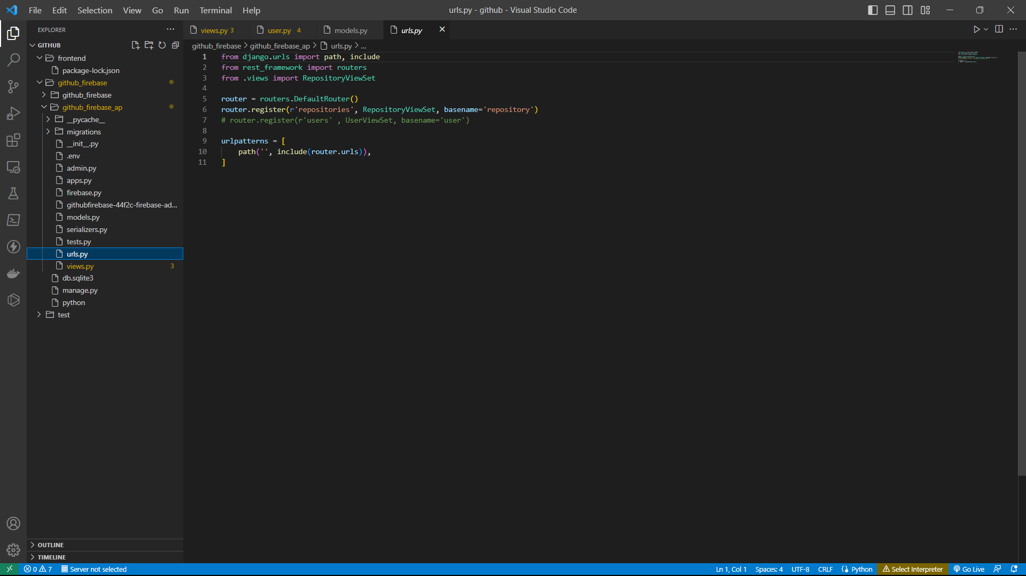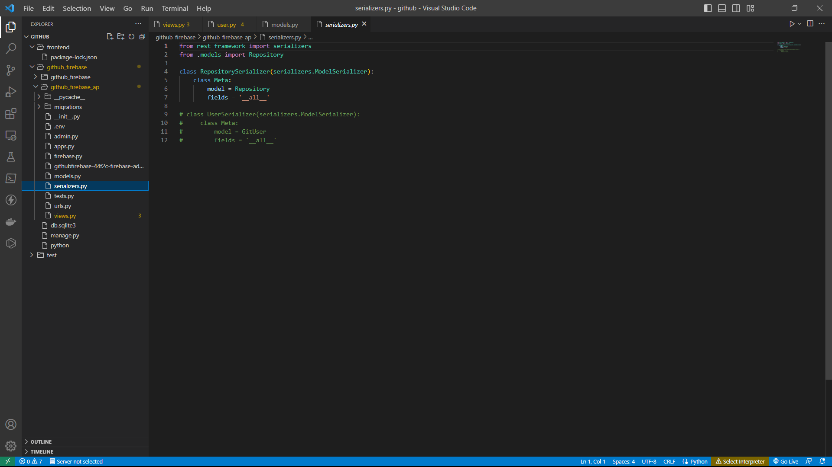
* **Testing the API (http://127.0.0.1:8000/api/repositories/)**

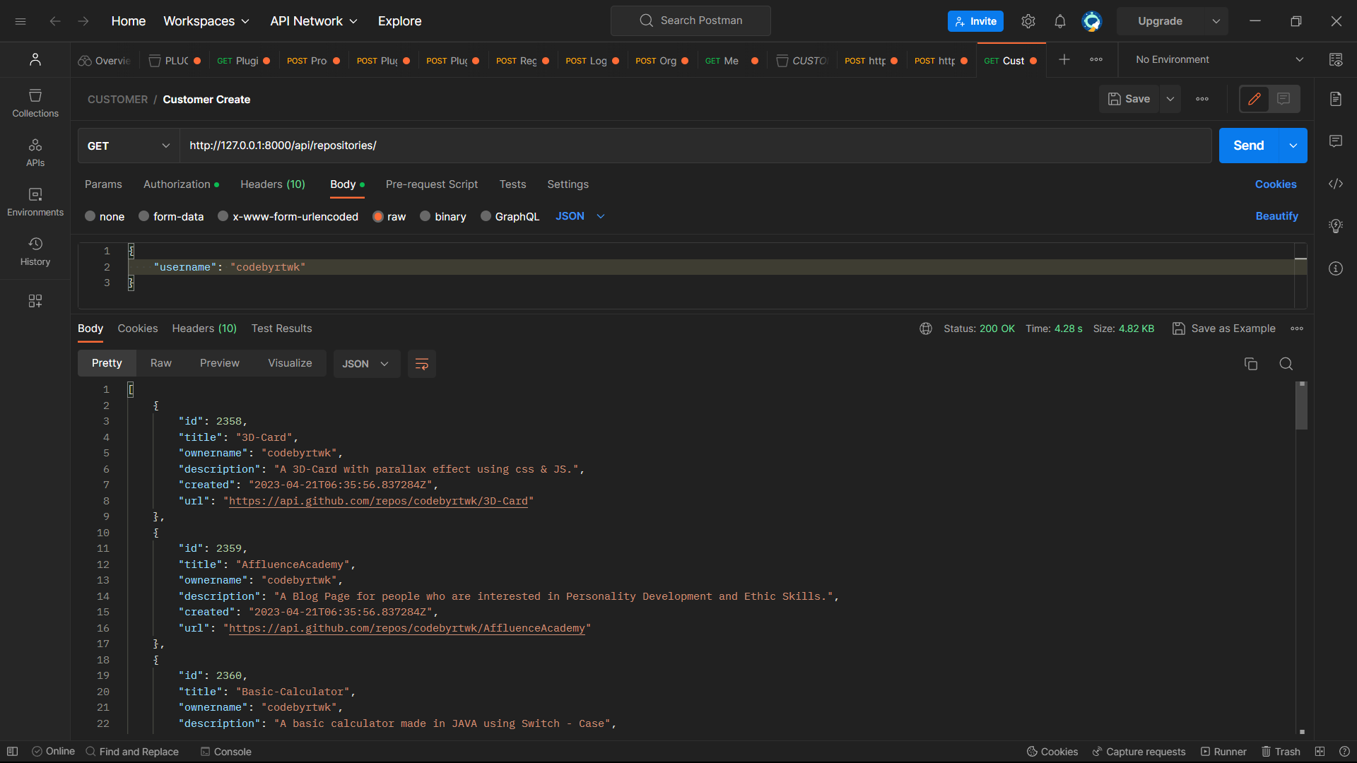

* **Testing if data is uploaded to Firestore**
* 